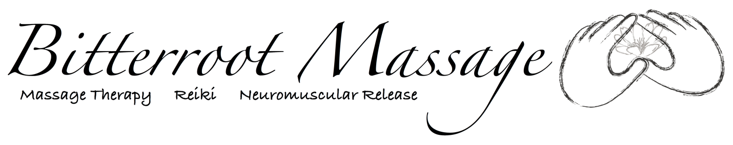Reiki Session FAQs

Who?

You or your loved one

What?
Reiki, an ancient Japanese healing technique, uses spiritually guided gentle touch to balance the body’s energy and connect it with the body’s power to heal.

Why?
Reiki relaxes the mind, body and spirit, and often helps reduce pain or assist the healing process.
When?
If you need to relax so your mind, body or spirit can heal, Reiki is for you. It can also help put your life back in synchronization

Where?
Bitterroot Massage is located in a home office in Hamilton, MT. Off-site massages / home visits are also available upon request.

How?
During a massage session clients will:
- Remain fully clothed
- Sit or lay on a comfortable memory foam covered therapy table
- Feel the practitioner’s hands gently on or above their head, heart, abdomen, legs and feet
- Sense deep relaxation and peacefulness, warmth, or a mild tingling

Reiki Reviews

"I feel very relaxed and less stressed now." R.W.

"The Reiki felt good, real good, and my back feels better now." K.W.

"Reiki healed my shoulder surgery faster than it would have healed." P.M.

Introduction to Reiki (5hrs) and Reiki I and II Classes (18 hrs)

Offered periodically throughout the year and by request. Call for details.

