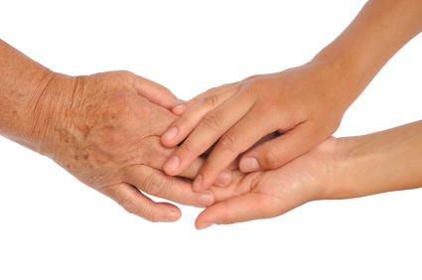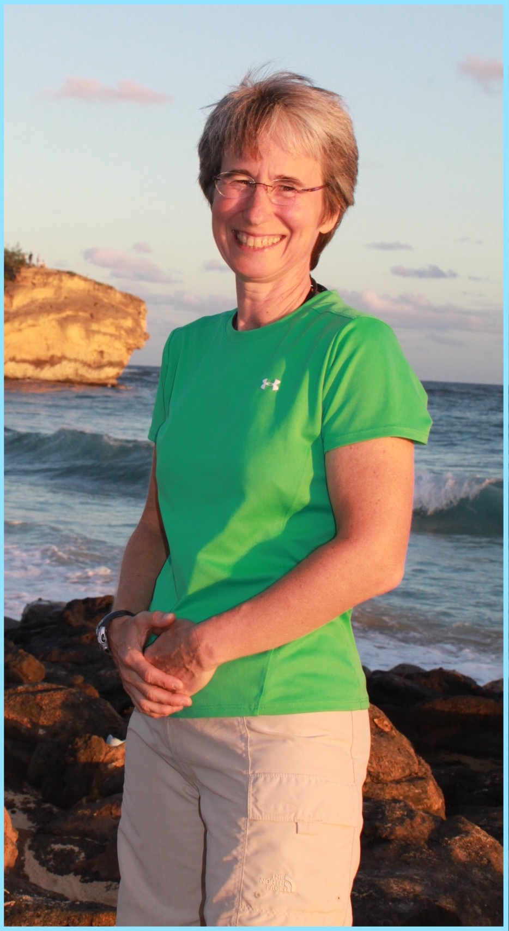

**Geriatric Massage by**

Phone: (406) 214-7031

Where Relaxation and Healing Happen

# Carolyn Durgin,

# Owner of

# 

#### Client Conditions

#### That Benefit From Massage:

#### Strokes

#### Parkinsons

#### Alzheimers

#### Wheelchairs

#### Diabetes

**Carolyn Durgin, LMT**

Certified in Geriatric Massage by

Day Break

Geriatric Massage Institute

Bitterroot Massage

(406) 214 7031

info@bitterrootmassage.com

# Why Massage?

Older people benefit from:

Enhanced Circulation

Improved Joint Mobility

Decreased Muscle Pain and Tension

Relieved Stress

Touch is an important way to communicate to older people that they are important as human beings. Touch also reduces feelings of isolation, helplessness and vulnerability..

# 

# Did You Know?

Massage:

Improves Sleep Quality

Boosts Immune Function

Stimulates Movement of Lymphatic Fluid

Improves Mental Alertness

Speeds Healing of Soft Tissue Injuries

#### Geriatric Massage by

#### Carolyn Durgin, LMT

# Call Carolyn

# (406) 214-7031

# to Schedule a

Wheelchair

Hospital Bed or

Table Massage

# At Your Loved One’s:

Long Term Care,

Assisted or Independent Living Facility,

Hospital,

Private Residence or

Bitterroot Massage