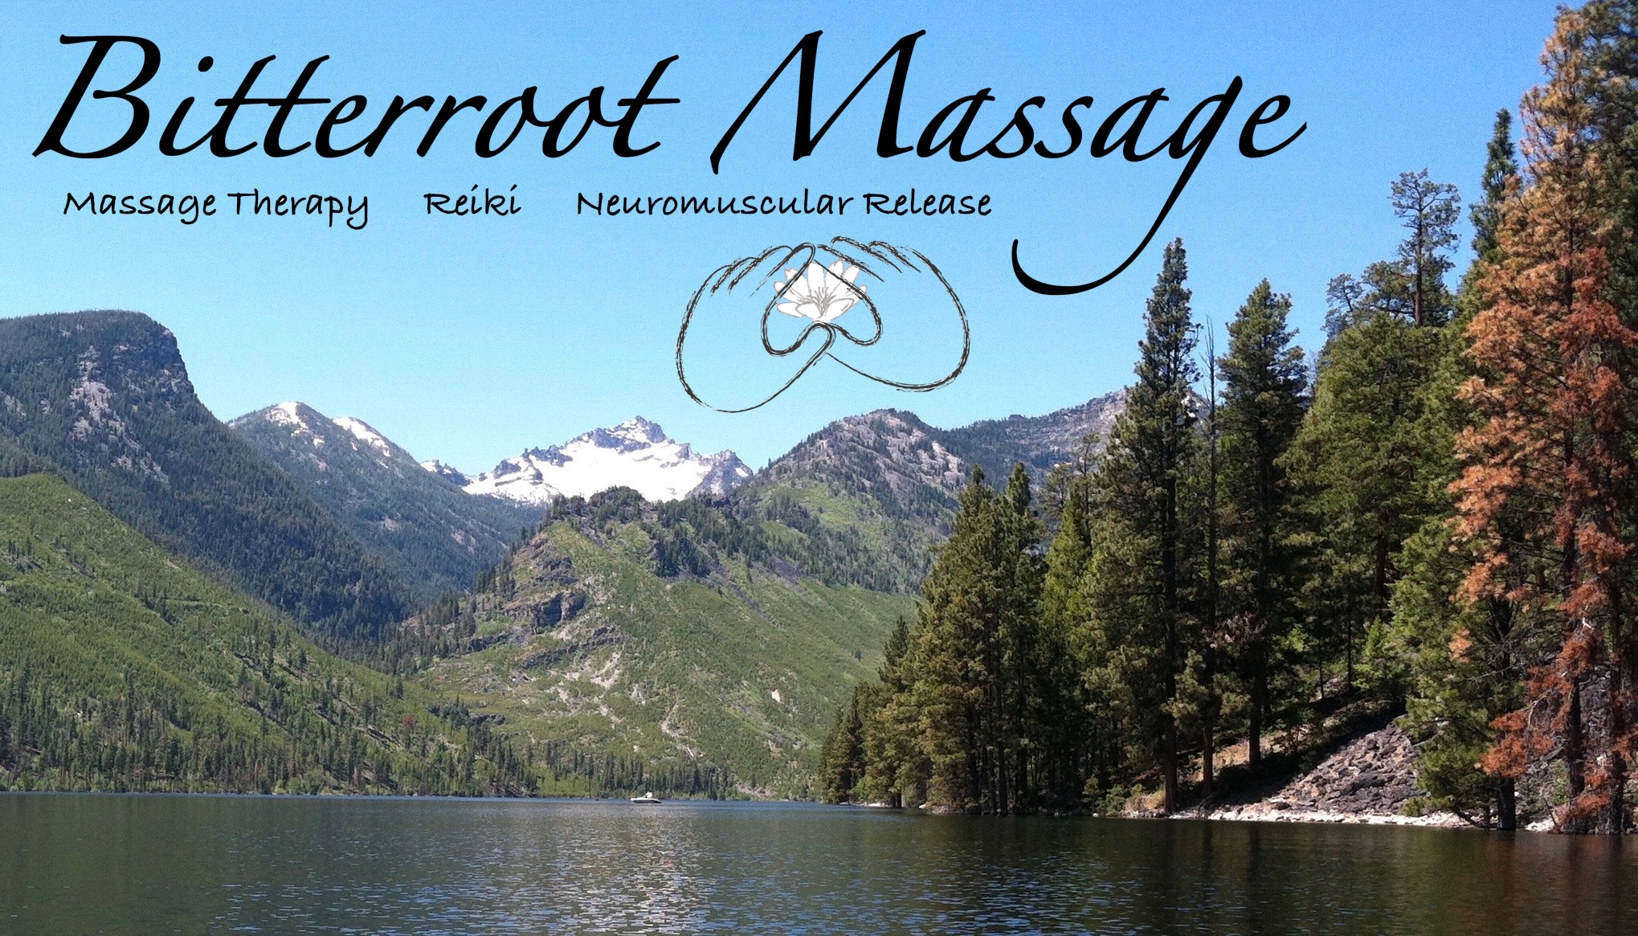

### Web

[www.Bitterrootmassage.com](http://www.Bitterrootmassage.com)

info@bitterrootmassage.com

International Academy of NeuroMuscular Therapies, St Petersburg, FL

Heartsong, TLC Corvallis, MT

## NeuroMuscular Therapy Certified

Massage Training Institute, Kalispell, MT

Day Break Geriatric Massage Institute, Indianapolis, IN

## Massage Training

## Geriatric Massage Certified

## Reiki Training

**Importance/Value:**

* Increases blood flow that cleanses, removes excess fluids, and nourishes cells
* Softens hardened muscles that make movement stiff or painful
* Soothes older adults as they cope with health issues and increasing fears

**Differences:**

* Conducted in a wheelchair, hospital bed or massage table in seated, supine or prone position without turning over
* 30 minutes
* Gentle and involves fluffing, a special massage stroke which combines long and kneading strokes
* No pulling or stretching
* Different strokes in surgical areas (avoids aggravating joint replacements)

**What Client Experiences**:

* Foot: gentle ankle pumping (dilates blood vessels), rotations (maintains range of

motion) and sole of the foot and Achilles tendon massage

* Leg: very light strokes (decreases swelling), long kneading strokes (helps return blood to heart); circular strokes (knee) and where appropriate, gentle hip and leg rotation
* Hand: gentle rotating strokes on palm only
* Arm: gentle long kneading strokes
* Traps and Pecs: kneading and quick light drumming strokes
* Scalp, Neck and Face: light strokes
* Back: gentle open-handed strokes from the sacrum to the top of the shoulder blades

### **Bitterroot Massage**

230 Merganser Lane  
Hamilton, MT 59840

**(406) 214-7031**

# **Geriatric Massage**

# **Carolyn Durgin, LMT Geriatric Massage Certified**