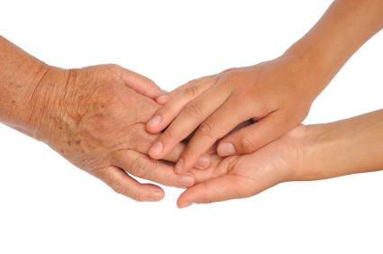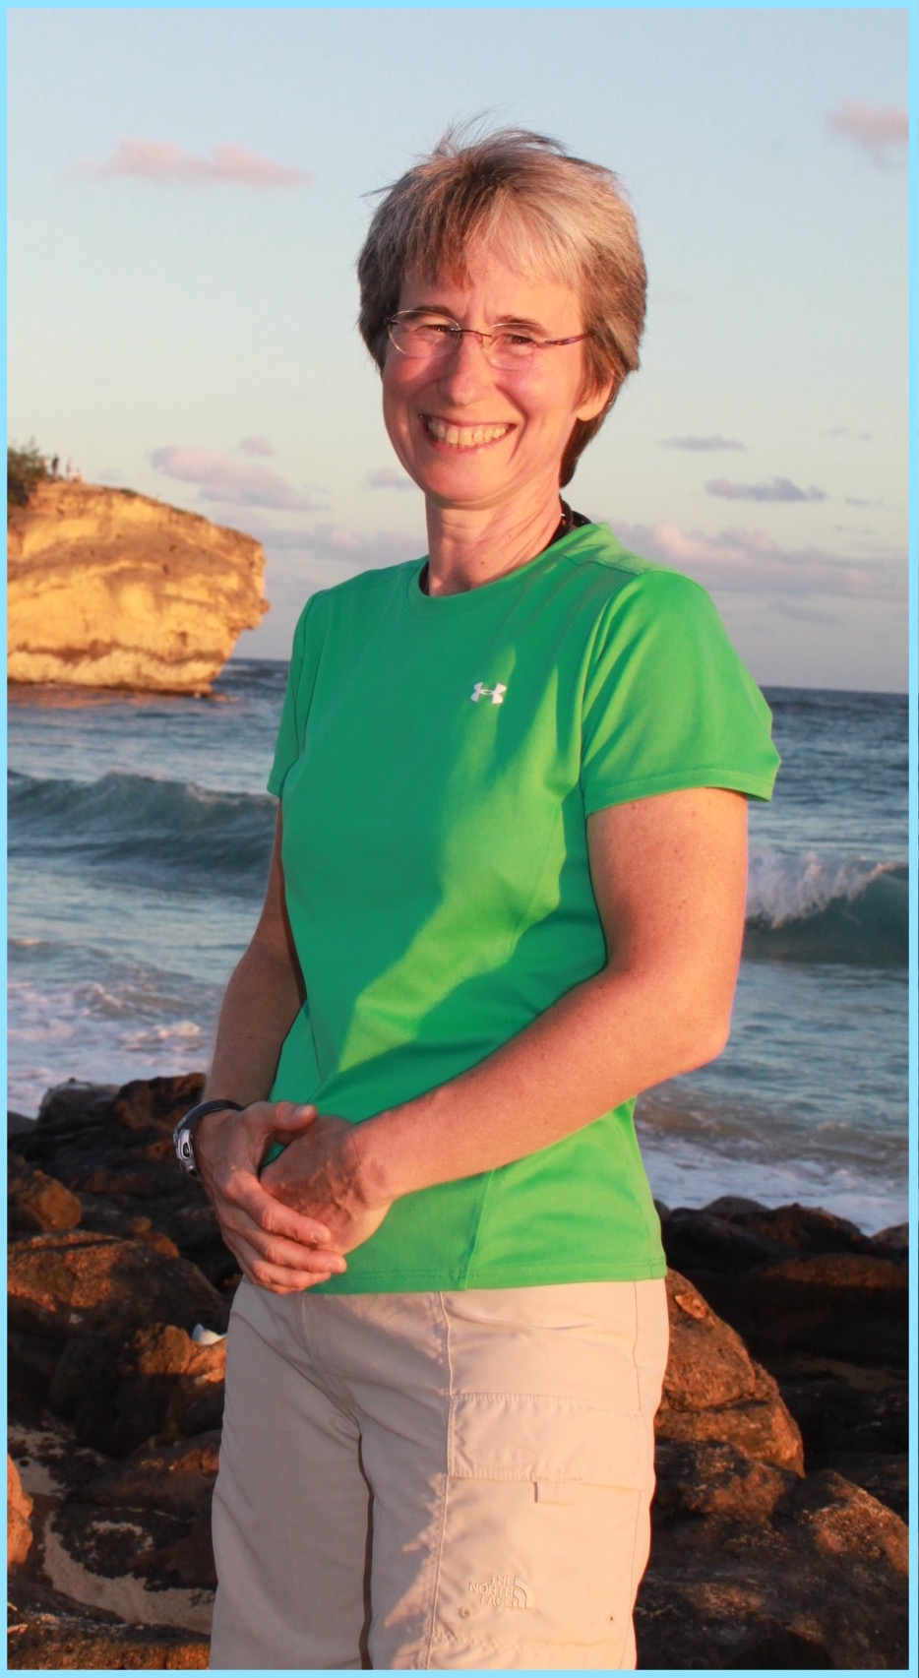

#### Strokes

#### Parkinsons

#### Alzheimers

#### Wheelchairs

#### Diabetes

Bitterroot Massage

(406) 214 7031

info@bitterrootmassage.com

Day Break

Geriatric Massage Institute

**Carolyn Durgin, LMT**

Certified in Geriatric Massage by

**Wheelchair & Hospital Bed Massage by**

Phone: (406) 214-7031

Where Relaxation and Healing Happen

# Carolyn Durgin,

# Owner of

# 

#### Client Conditions

#### That Benefit From Massage:

Touch is an important way to communicate to older people that they are important as human beings. Touch also reduces feelings of isolation, helplessness and vulnerability..

# Call Carolyn

# (406) 214-7031

# to Schedule a

Wheelchair

Hospital Bed or

Table Massage

# At Your Loved One’s:

Long Term Care,

Assisted or Independent Living Facility,

Hospital,

Private Residence or

Bitterroot Massage

#### Wheelchair &

#### Hospital Bed Massage

#### by Carolyn Durgin, LMT

# Why Massage?

Older people benefit from:

Enhanced Circulation

Improved Joint Mobility

Decreased Muscle Pain and Tension

Relieved Stress

# 

# Did You Know?

Massage:

Improves Sleep Quality

Boosts Immune Function

Stimulates Movement of Lymphatic Fluid

Improves Mental Alertness

Speeds Healing of Soft Tissue Injuries